Create a custom docker image for nginx and deploy it using docker compose, where the volume bind mount should be at /var/opt/nginx location. Push the created custom docker image to your docker-hub.

**Solution:-**

Created Dockerfile and index.html file

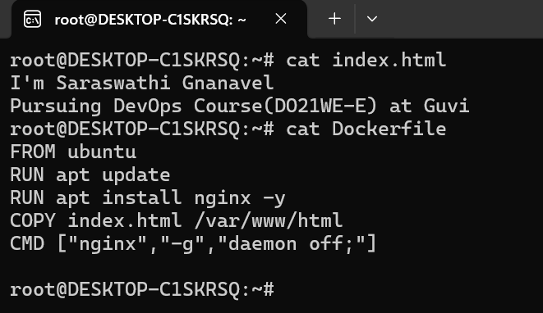

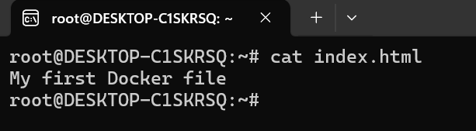

Building docker image, nginx:v1 has been build successfully

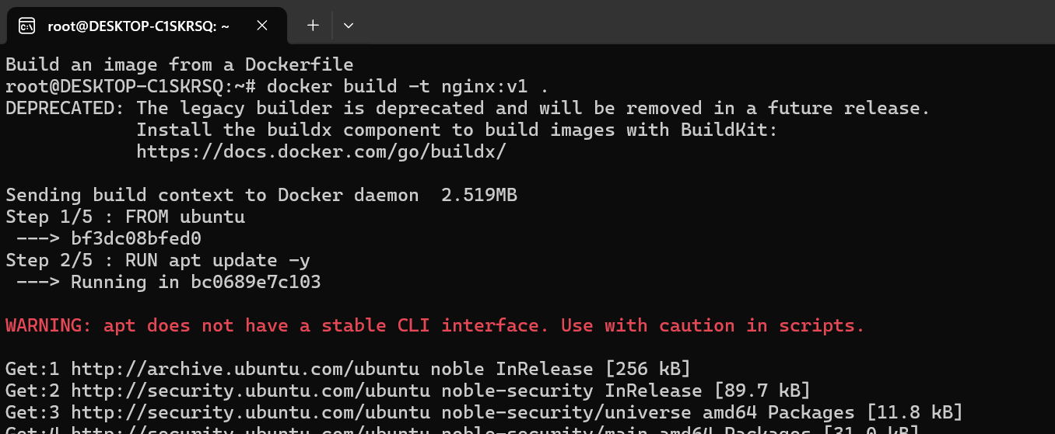

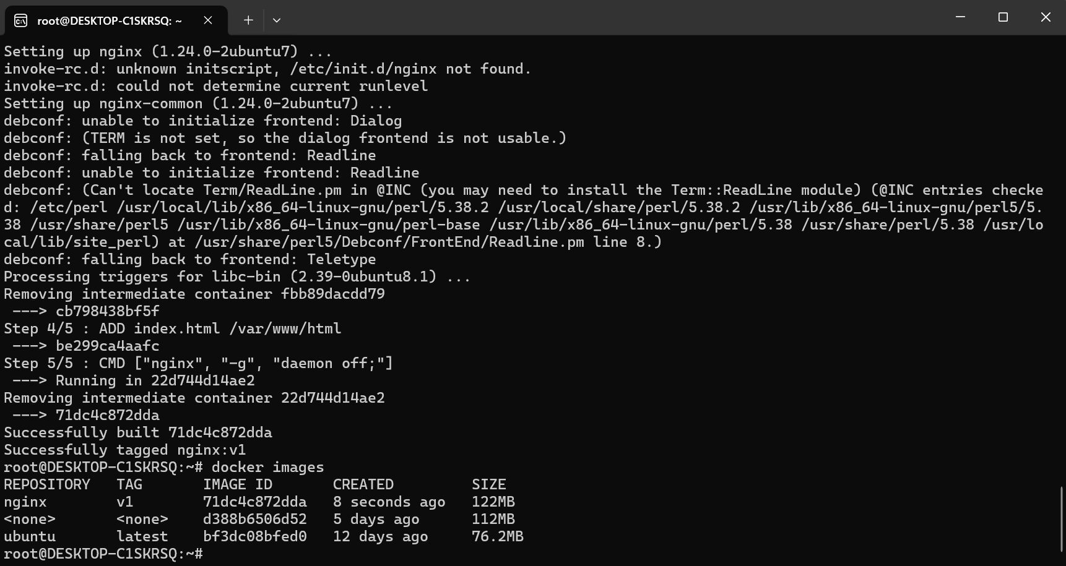

Installed docker-compose

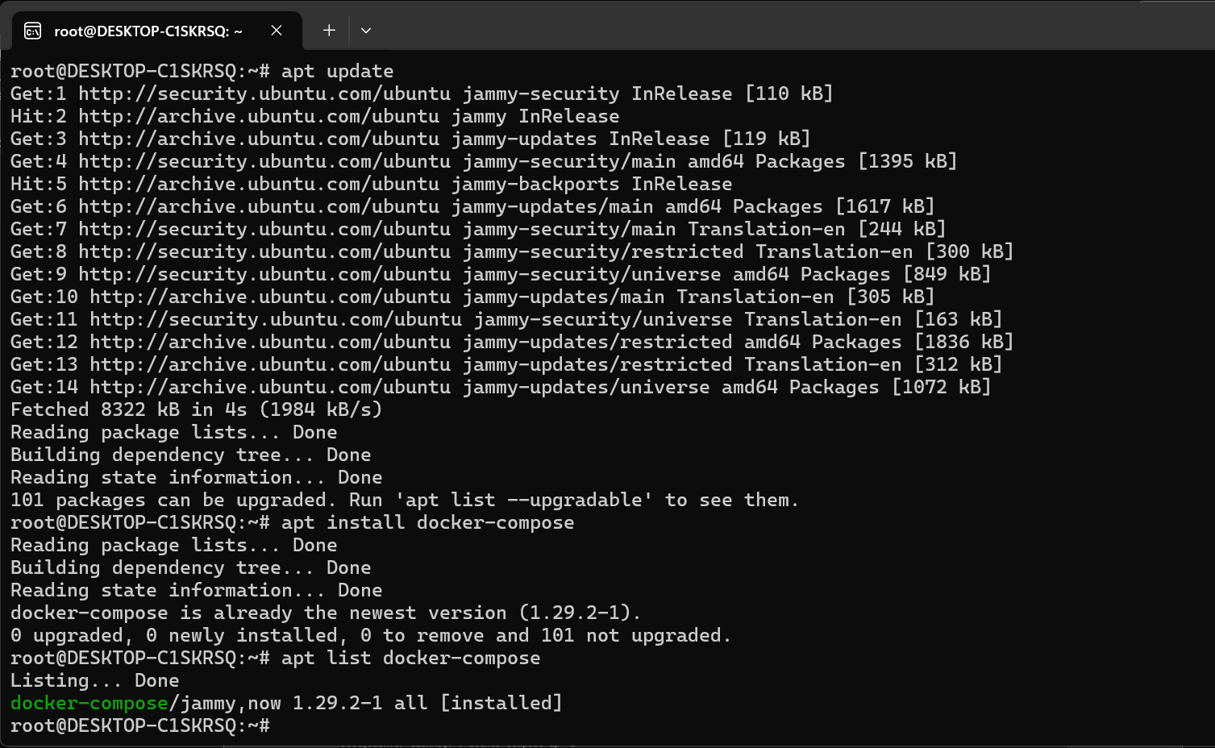

Created docker-compose.yml file to run the image and generate non-ephemeral volumes

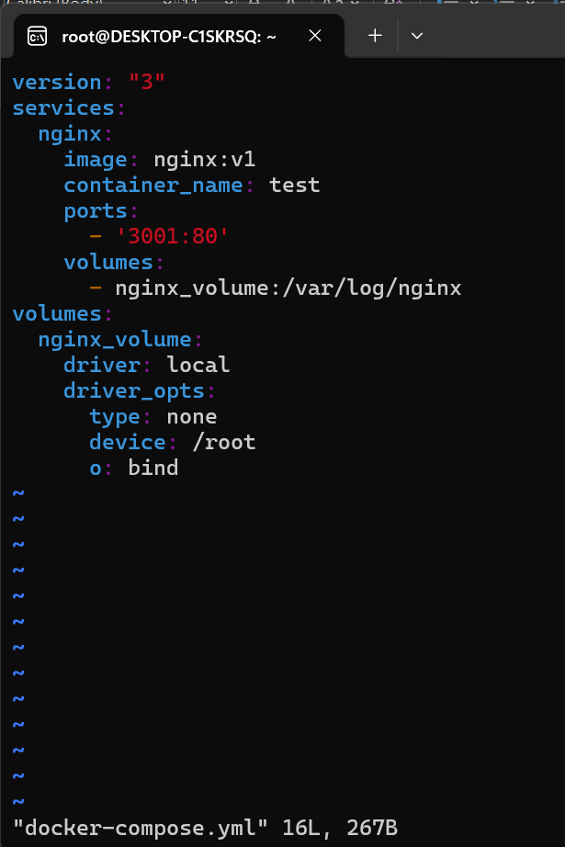

Running the container using docker-compose

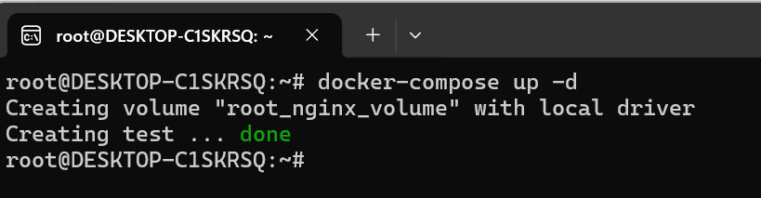

nginx container is running

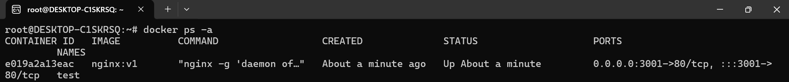

You can find the expected output when you browse using the given port number

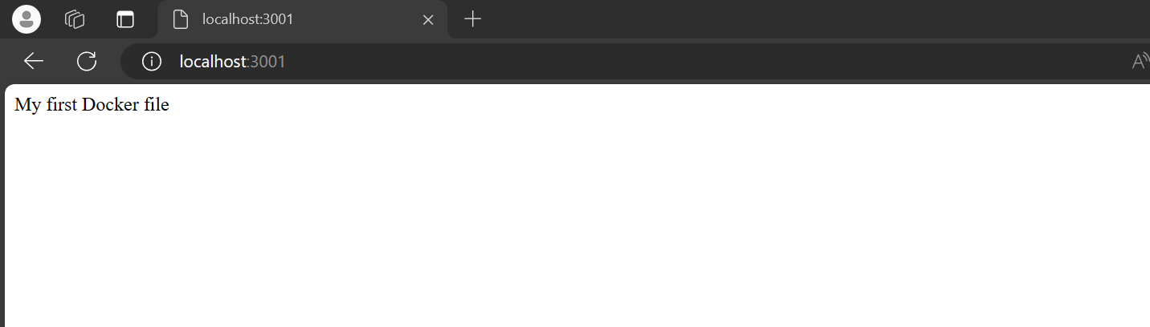

Both access.log and error.log has been generated in our local machine using docker volume🡪 root_nginx_volume

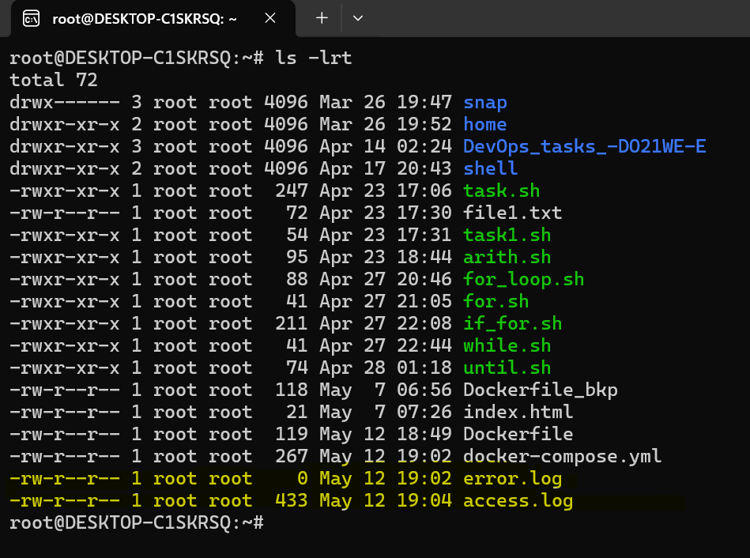

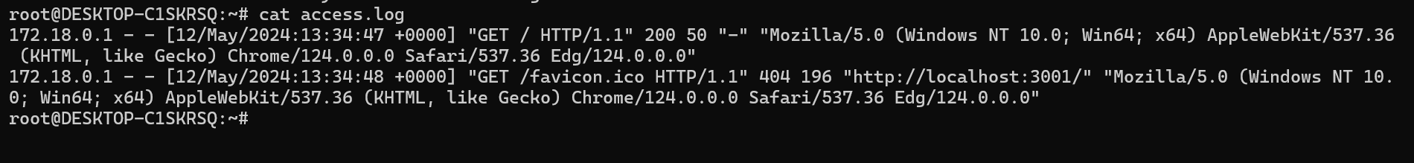

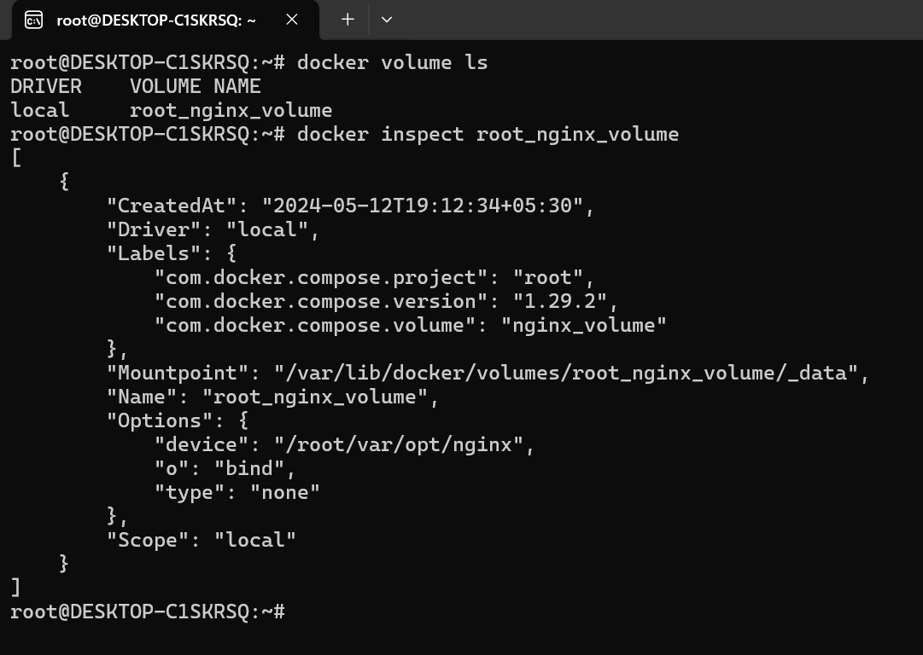

Stopping container using docker-compose

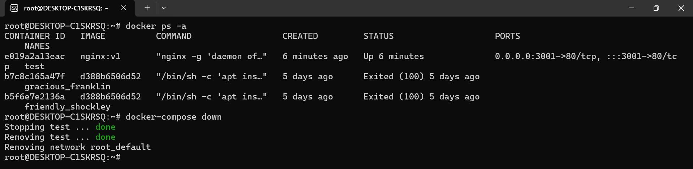

Pushing the created custom docker image(nginx:v1) to my docker-hub, firstly renamed existing docker image’s repo name into Docker hub repo name(sara1327/nginx:v1)

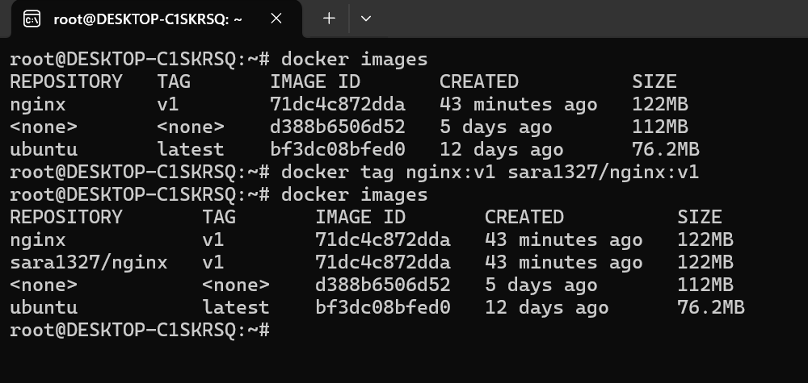

Logged into docker hub from ubuntu to push the docker image

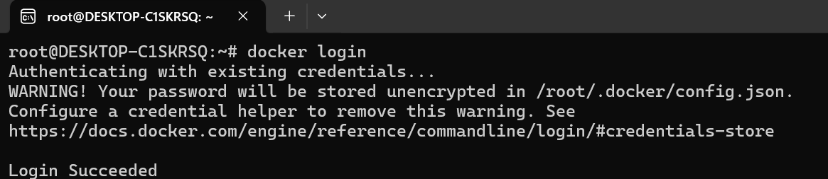

Successfully pushed docker image(sara1327/nginx:v1) into docker hub

